PROBLEM:

Water can leak into the [LHS] of the foot well closest to the centre tunnel under the dash when washing the car or it rains. Basically, it can make its way through the blower somehow and into the car.

COMMON CAUSES:
- The elephant trunk drains can block up with leaves and mold / fungus.
- Water can make its way from the windscreen and directly into the blower area due to the windscreen drain channel and / or the rubber barrier has been damaged.
STUFF REQUIRED:
Plastic prying tool
Battery terminal or small parts puller tool
Degreaser, rags, gloves
Wrench with 17mm socket
Sealant or window/door weather strip
Marking per or pencil

PROCEDURE:

We will be removing the cover Cover removed ready for cleaning
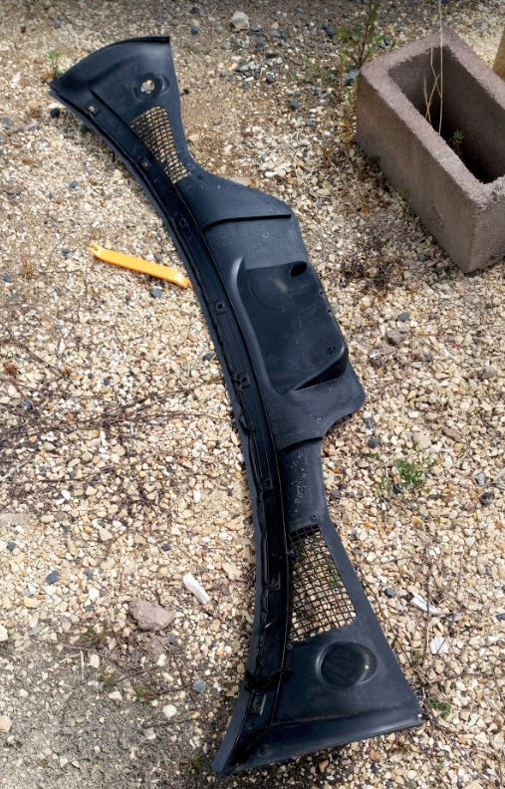
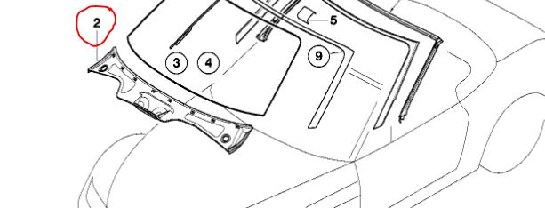

- Open the bonnet.
- Ensure that the ‘recycle air’ button is activated [car must be started or key in position2] as this will close the flaps on the blower making things easier later.
- Using a plastic pry tool carefully lift the ‘rectangular push in tabs’ holding the plastic cover on the end of the windscreen and car body - there are 8 of them. Below shows the push in tabs partly inserted in the clips.
- Pry off the ‘push in clips’ that were under those push in tabs.
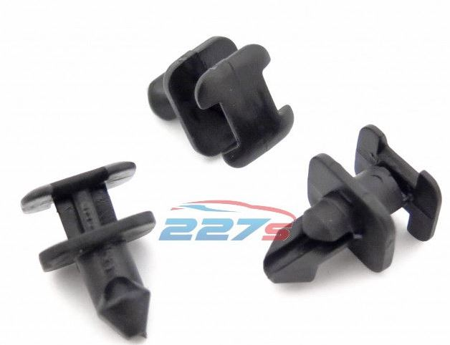

- Remove the large rubber channeling and pull up the smaller rubber channeling each side to get it out of the way; indicated by the red lines in the picture. This will help you to lift out the plastic cover.
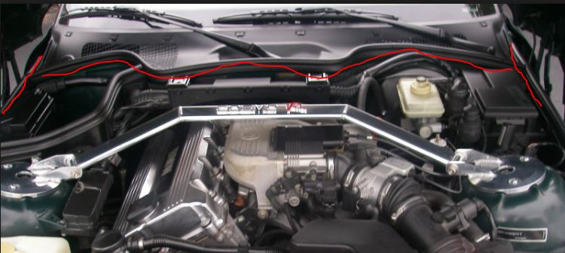

- Remove the Rubber caps on the windscreen wiper arms where they bolt onto the car. Then, use a white pen to mark the location of the wiper arms.
- Remove the 17mm nuts holding in the wipers.
- Use a battery terminal puller or small parts puller to remove the wipers.
- Now, the plastic shroud will pull away easily exposing the blower.
- Clean out the entire space of any debris. A vacuum cleaner is recommended.
- There are two elephant trunk drains below the blower which drain water into the engine space. Ensure these are clean and are draining properly.
- In my case the windscreen must have been replaced and the technician got silicone in the channel just under the glass. Clean this out so there are no obstructions.
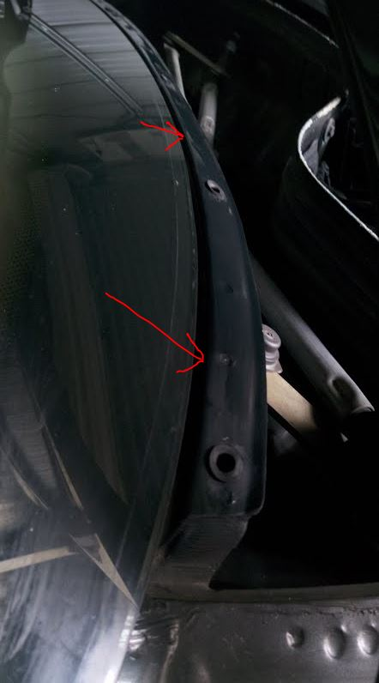
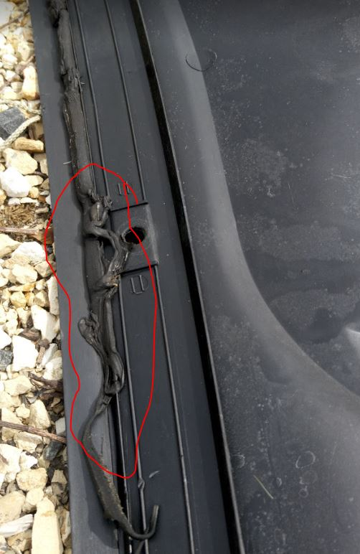

- Look on the back of the plastic cover. In my case the factory installed rubber was displaced and allowed water to run down the windscreen and directly onto the blower. Remove all of this sticky black rubber as it is designed for a single use anyway.
- Spray degreaser on a rag to clean it off. Also ensure the window and the channel are clean. I then ran a rag with some isopropyl alcohol on all surfaces to ensure they are perfectly clean.
- I found that the best thing to replace the black sticky rubber is stick on window insulation. This is easy to apply, no mess, can be removed easily, and will not be damaged if you have to remove the plastic shroud again in the future. I will have to do that because I will need to replace the sealing foam in the blower vents when I get the parts.
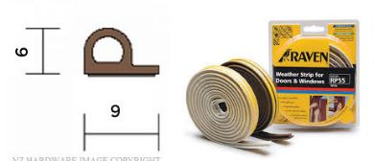

- Sick the rubber onto the windscreen glass as low as possible. Ensure you use the 2.5 -5mm P shaped rubber or similar. Test fit the plastic cover to ensure it fits well and looks good.
- Might as well clean everything you can get access to.
- Re-assemble in opposite order then test.

Procedures by: Graeme Cooper

